Laura Gale

Front End Web Design

Assignment 3

Rationale

U3141006

**Why I chose Tocumwal**

The decision to base my website on the Tocumwal Archives information was quite an easy one for me. I found the content to be richer, especially the images.

I found the content to be divided in an organised matter which helped when organising the navigation on my site and allowed me to focus more directly on my website design itself rather than the actual content.

I am a very visual person, all of my favourite go-to websites are visually enticing and appealing. I find the experience on a website really depends on the visual appeal. Most of the websites I spend time on are either sport or news based, or online shopping. I find both to display a lot of colour and big images to either tell a story or sell a product.

More on what makes a website visually appealing:

<https://enablewebdesign.com/makes-website-visually-appealing/>

For this reason, I chose to base my home page on a visual appeal. Using images with buttons to lure in readers as this is something that works for me. This is the background for my home page design choice. I enjoy images and basic navigation as I am not a very tech savvy person or someone who spends a lot of time on the internet.

My seven webpages consist of this Home page modelling a substantial image design then branches out to six other pages. These included:

* Tocumwal Background
* Heritage Listing
* Origins
* From Tocumwal to Canberra
* Early Years
* Parties and Pastimes

**Navigation**

The navigation on this website was quite simple. It resides at the top of the page at the left-hand side and with the images in the middle of the Home page. I found that the Home page acted as an introductory title page, and although it isn’t exactly the same as the other six pages I didn’t find this confusing and don’t think anyone else would. The Home page is there to make a statement and I believe it did so, however keeping the same design throughout the rest of the website helped to maintain continuity.

I found this navigation choice to allow the user to navigate through the different pages with ease as the navigation function is always going to be at the top of the page and is seen on all pages.

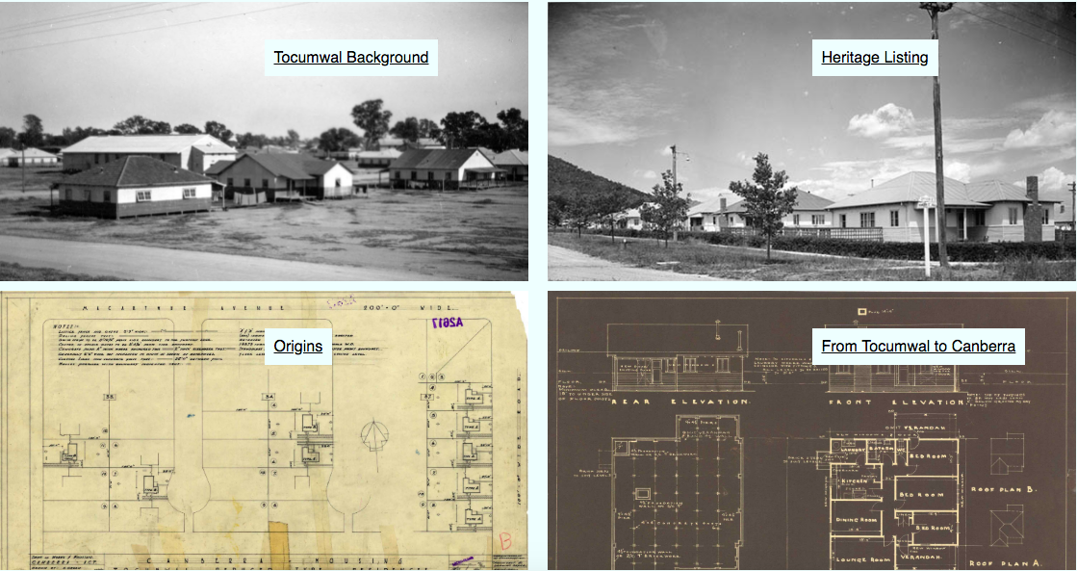

**Design choices on my site**

I am visually impaired and often can struggle using different websites especially on my phone. The colour choices may be bland to some people on my website but I believe they are easy to read by anyone. I used the “azure” light blue background with a black text, I also used a sans-serif black text for my navigation headings.

I cannot read red or orange on a white background which was a struggle I have had to deal with throughout high school and university. However along with other people with vision impairments or different types of colour blindness blue paper is often used to overcome that, hence my choice to use the azure background.

I felt the azure background helped with usability and ease of reading, not just for myself but with family and friends who I tested this on. I though the red was a nice pop of colour as the rest of the design can be quite similar.

I chose the layout of the navigation menu at the top left part of the page as I wanted to encourage the user to read the page from left to right. Utilizing this element encourages the eye to naturally start from the top left of the page and continue to descend.

More information about reading left to right, top to bottom:

<https://uxplanet.org/z-shaped-pattern-for-reading-web-content-ce1135f92f1c>

I found the azure blue to work in well with the images too. Many of the images I used were either black and white or vintage-yellow old paper, and I found the blue worked well with that. It looked professional but didn’t draw attention away from the image or the content.

**Designs that inspired me**

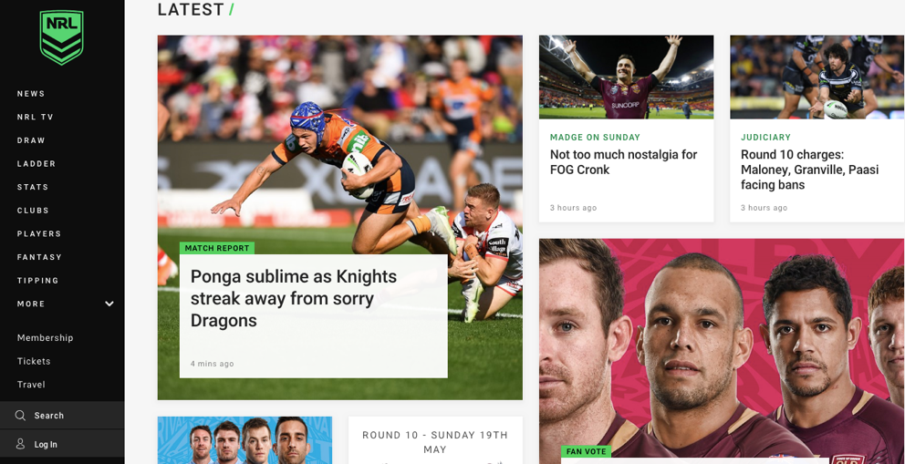

I don’t believe there were any websites that particularly inspired my design choice to have the navigation at the top left corner of the [age, however this can be a common choice on websites. I do believe however that the use of many pictures was inspired by these main websites. As a sports media student, I spend a lot of my time on the internet on sports websites and sports news websites, both show a lot of colour and pictures to engage the audience.

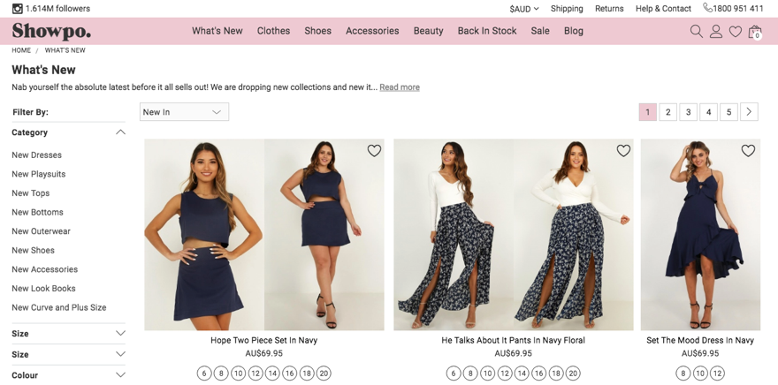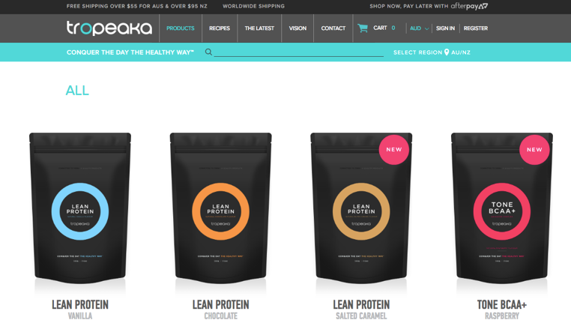This can be seen with my other two examples as well, both online websites. Showpo and Tropeaka are two main websites I use for online shopping and both display colour and images as a selling incentive. The hero images on these websites draw the user in and the easy navigation enables stress-free use.

**Overall approach that guided the design decision**

Although it may be hard to see similarities from the websites that inspire me, especially in colour choices, I did draw attributes from these websites and used them on my own. Especially using the images as the hero piece to make a statement and keep the user engaged.

I found that none of these websites used a home title page to make a statement as such. However, they all have their recognised brand or logo in the top left hand corner which makes a statement in itself.

As I am very new to web design and coding I will admit I tried to keep my design on my website as basic as possible. I have never done anything like this before and didn’t want to put myself at even more of a disadvantage by aiming too high. I still challenged myself and found this unit to be the hardest I have ever done, so in no way was it a cop out or slack, I wanted to create a balance of challenge and realistic goals.

I also found Riley’s knowledge and advice in tutorials to play a huge role in the design choice of my website.

**Reasons for design decisions**

The NRL website, Showpo and Tropeaka all lacked a title home page. A home title page was something I was adamant from the start that I wanted. I felt with the richness of the content and the images from the Tocumwal Archive would be best displayed with a rich home page. I found inspiration in this idea from the AS Colour website.

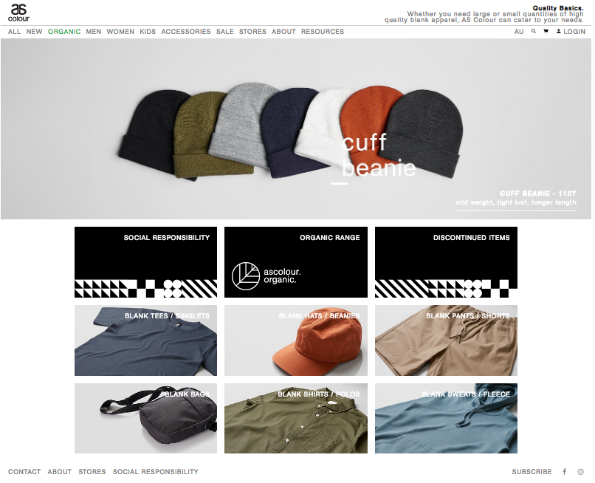

These content boxes on the index page or home page are hold the lead content to each section and are a great pathway to introduce that. I wanted to do this from the start as that was how I visualized my website in my head from the beginning, however seeing this on the as colour website was very reassuring. Hence why I continued to do this on my own website, creating the content boxes to hold each of the six links.

As mentioned already, my design choice for colour and font came down to my own visual troubles and experiences and I believe it to be the right choice as I also tested this on family and friends and all read and digested the content with ease and calmness.

**Description of challenges you encountered and how you solved them**

I have been faced with more challenges in this unit than I have in my whole degree. I don’t come from a design background, nor have I ever done any web design or coding. This unit was completely foreign and new to me. I don’t even consider myself to be very tech savvy in general.

I am so grateful for the one on one time I was given in class. In each class, towards the end if the other students in the class were all up to date and weren’t needing assistance, Riley spent time sitting with me trying to catch me up and help me.

One of the biggest challenges I faced was the speed of class delivery. As I didn’t understand a lot of the content being delivered or the terminology it was extremely hard for me to keep up. Especially as Riley knows his way around a computer keyboard so he uses shortcuts for absolutely everything, I’d be trying to learn the short cut and he’s already be three steps ahead.

I believe Riley was by biggest solution to this problem. The amount of time he has devoted to helping me both face to face as well as through email has been such a huge help. I believe I wouldn’t have learnt so much from this class if I had a different teacher.

Another challenge I faced was using brackets as the code used the colours red and orange. As red meant there was an error somewhere, that’s pretty self-explanatory for most as it stated exactly where the error was and it’s pretty simple to fix. However, I couldn’t differentiate between the red and the orange as it was on a white background. I initially laughed when a class mate pointed this out to me as I didn’t know there were two different colours and thought “I’m screwed”.

To overcome this I constantly had my classmate and Riley check over my work to inform me of any red code. I also had to zoom in quite far at times and adjust the brightness of my laptop to different brightness’s to determine the two different colours.

As for other technical challenges that I faced, I struggle with css. I actually found html quite fun and I enjoyed the first assignment for this reason. I really thought I was on top of it and had a decent understand of it. However, when introducing css I struggled to keep on top of things after that. That added element confused me quite a lot.

To overcome my confusion with css I just learnt to “play” around with it. In order to get different attributes and images in the correct places and to the correct size that I wanted I would often seek help, then play around with different sizes to come to a conclusion.

Other issues I came across I found could be fixed quite easy. I had to look through the code to find out why something was being stretched or behaving in a certain way. But eventually the issue would be rectified.

Another huge help when I was faced with challenges was the use of the W3C validator. This helped with errors a lot, especially as some of the errors were minimal and may not show up on the website straight away or I may not have noticed them, so they were shown in the code as red. As I couldn’t see the red, the W3C validator was instrumental in the process for that reason. A great tool to identify issues.

YouTube at times was a friend and an enemy. I found it really helped me to understand what I was doing, what I was trying to achieve and what I may have been doing wrong. It really helped me in that sense. However, at other times I found it introduced me to a more advanced level that I may not have been ready for. I’d try to incorporate this into my code and then take it to Riley in class and confuse myself because my level of understanding and knowledge didn’t match what I had included in my code. For this reason, I found it was a great tool to help me with any questions I may have and assist with clarity, however, I still took questions and issues to Riley so I was able to get an explanation suited to my level of knowledge.

**Consideration of any usability or accessibility issues you encountered**

I had issues with my website when changing from a desktop view to a mobile view. The two columns on the index page posed as an issue and at the start I wasn’t sure how I could solve that. Obviously on a desktop or tablet view having two columns of images isn’t an issue, but it got way too small on a mobile view. I had to do a lot of work using the WAVE Accessibility Evaluation Tool. I had so much trouble even getting this tool started. I added it as a chrome extension on my browser however I couldn’t figure out how to open it like I did when it was a normal website. I had to open my Tocumwal website on chrome then right click the screen and press inspect. I’m not sure if this was the right way but it was the only way I could get it up on wave to work out my sizing issue. I then had to add code to my css to rectify the problem after testing this issue multiple times at multiple sizes.

**Mock ups and wireframes of your sites design**

I did a rough sketch for the design I wanted in class just on the notepad I had on me at the time. I then went and did this properly using wireframe.cc.

<https://wireframe.cc/>

Originally, I had kept the same home page design across all view sizes (desktop, tablet and mobile). However, I found that on the mobile view, the two columns got messy and difficult to read. So I decided to have just the one column for the content images for the mobile view and keep the two columns for desktop and tablet.

Desktop Tablet

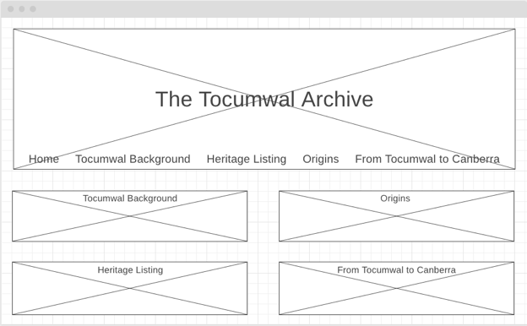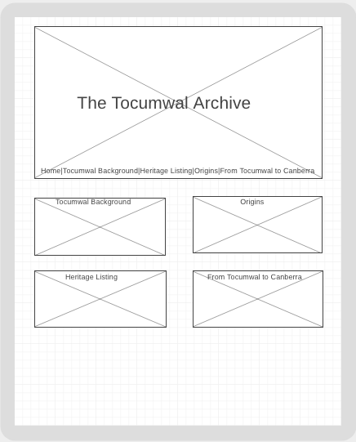

Mobile option 1 Mobile option 2

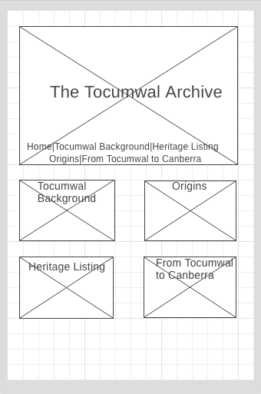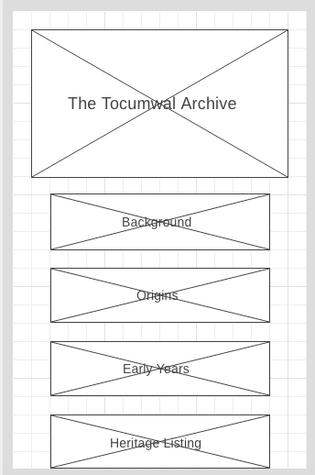

I also made another design change by using the wireframe.cc tool. Originally, I had navigation buttons on the home page along the bottom of the hero image as well as inside the content images but for no apparent reason. It was overkill and unnecessary hence why I decided to change this in all three formats final design.

**Annotated list of resources that you found helpful while creating the website**

Resources

<https://www.showpo.com/checkout/cart/>

<https://tropeaka.com.au/collections/all?gclid=Cj0KCQjww47nBRDlARIsAEJ34bkCVUCqtudmqVTpKB2T4_Q4Juo-mhj-Hd4EJv1wskL-JIbIlWx-uQsaAjRvEALw_wcB>

<https://www.nrl.com/>

<https://www.ascolour.com.au/>

<https://wave.webaim.org/>

<https://wireframe.cc/>

Desktop view

<https://wireframe.cc/pro/edit/245913>

Tablet view

<https://wireframe.cc/pro/edit/245916>

Mobile view

<https://wireframe.cc/pro/edit/245920>

<https://www.youtube.com/watch?v=kmVrFwkI9Fw>

<https://www.youtube.com/watch?v=yfoY53QXEnI>

<https://www.youtube.com/watch?v=gQgqJG8ld7M>